**Application Development-CW1**

House Hold Management System for E-Shift

**GitHub Link :**

<https://github.com/sula92/E-Shift.git>

# Name : Sulakkhana Indeepa Dissanayake

**Student Number : 00125085**

# CHAPTER:01.INTRODUCTION

## 1.1 Introduction

E-Shift is a House Hold shifting company which performs its business locally throughout Sri Lanka along with many branches in Sri Lanka. It is very famous for its dedicated works over twenty years. They provide best services to the customers in all over the country.

Company is using Microsoft excel to insert all the data. As well as some of the data is inserted in books manually. Data redundancy, less integrity and inaccuracy, delay in decision making due to unavailability of timely reports are the main problems they overcome in their company. Current system does not fulfill their business-based requirements sufficiently. The new system will solve these problems and attain efficiency and effectiveness.

Solution is to use the stand alone application which is developed in C# to cover administrative process to achieve organizational goals and objectives. New developed system assists to carry on procedures and functions of Customer management, Employee Management, Lorry management, User management, Unit management, Job management and Product management for the purpose of managerial decision making.

The System can be logged in using a Username and a Password. This can be accessed by Administrator and registered customers. Data can be retrieved easily. The interface is very user friendly. This System has been developed based on Rational Unified Process (RUP) framework. C# is used as the main language. Additionally, XAMPP is selected as the database server to store data of the system.

The developed system is thoroughly tested using a complete procedure and evaluated with user to determine whether the system user requirements are obtained. The system confirms to the specification whilst providing the intended functionality of enhancing efficiency and effectiveness. Main goal of this system is to smooth line the process in E-Shift.

## 1.2 Motivation for the Project

E-Shift is one of a famous Shifting company in Sri Lanka. It is in business since 2000. However all management activities and inventories are being handled mannually. Customers and the management face many difficulties in completing their tasks. Hence it is being forced to spend more time and more effort to complete such tasks.Therefore a computerized system was requested by client to overcome these issues.

The motive to develop an window form application. Currently the Company does not have a proper automated system to manage their routine.

Currently the business is done using Excell and mannual methods to handle these activities.

* Registrations
* User Management
* Employee Management
* Customer Management
* Product Management
* Unit Management
* Job Management
* Lorry Management
* Container Management

Many difficulties and improperness are faced by the Employees of the Ranjith company during the management of the school.

Specially they faced difficulties such as

* All the information is stored in a physical document-based system
* Lack of security
* Difficulty of managing multiple customers
* Higher level of data redundancy
* Management has to inform the students about the exams, trials, lectures over the phone.
* Current manual system is error prone.
* Inconsistency in maintaining data.
* Difficult to manage information about customers, employees, jobs.

The objective of this project is to develop an Window Form Application system for E-Shift and its subordinates to over come the above mentioned difficulties in an easy,accurate and efficient way.

## 1.3 The Scope Of the Project

The main goal of the system is to provide an efficient way to analyze the process of the company with minimum cost,time and human effort. System can handle daily procedures of the company accurately and efficiently by reducing the overhead caused due to current work.Administrator can maintain the system by updating, Adding and viewing the details of the above mentioned entities. This System is user friendly for cutomers which reduces the burdens and help to manage the all sections related to them such as viewing job status, profile info , request for jobs.

**Scope of the system**

## Fuctionalities of Administrator

Below are the basic functionalities that the system is capable of performing.

* User Level & Access Management:
* Only the administrator has the privilege to manage the customer and grant and revoke the access permission.
* Customer Management
* Manage all functionalities of Customers.
* Adding new Customers to the system and provide access to the system.
* Employee Management
* Employees can only be managed by the administrator.
* Manage employees and allocate them to units.
* Unit Management
* Admin can add new units.
* Administrator can assign employees and a lorry to a unit
* Admin can edit the unit details
* View unit details
* Lorry management
* Add, update lorries to the system
* View the Lorry Info
* Job management
* Exam date is updated here when the government change the dates
* Manage and maintain the exam and trial information
* View results
* Product Management
* Upload video sessions that has been conducted before and past papers to the system. Students who missed the lectures can watch them

## Functionalities of Customer

* User Registration
* Once Customer/Employee registered in the system, they will get the permission to access their profile after admin gives the access.
* Secure Login
* Customer can login to the system by providing their username and password.

* Request For Jobs
* Customer can request for jobs
* Customer can view requested jobs
* Customer can update product Info and cancel a requested job
* Manage Customer Profile
* Customer should be able to login and manage their own profile.

## 1.4 Objective of the project.

* To Improve the efficiency and maintainability.
* To Minimize the time taken to handle Registrations
* To Minimize the work load of the company along with its employees.
* To maintain smooth cus management process by improving the reliability and efficiency of the company.
* To easily register new customers as and handle jobs

## 1.6.Project Plan



# CHAPTER: 02 – ANALYSIS

## 2.1.Introduction

This chapter consists description about the functional and nonfunctional requirements. Furthermore, the techniques used to gather necessary information is described extendedly. Requirements gathering and analysis is the main part of the project since poor and unclear objectives will definitely lead to an unsuccessful results. Domain understanding, requirements gathering, classifying and prioritizing functions are the main activities carried throughout this phase [2] [3].

## 2.2.Fact Finding Techniques Used

### 2.2.1. Interviews (Employees)

Interviewed randomly selected employees in-order to get a clear view of the current system of Ranjith company and to clarify doubts about the management procedures related to managerial level of the Store. Interviewed two employees of Ranjith company to get an idea about the problems they face with the current running system in their school. Interviewhas an overall idea about the project as well as the way it should look like [2].

### 2.2.2.Observations

Some more special things could be crept up through this technique which cannot be analyzed through documentation. The process of the Ranjith company was explored without interrupting their daily routine. By using this fact gathering technique we could understand the difficulties they face without a proper automated system to handle their tasks as well as time they waste in some situations.

### 2.2.3.Questionnaires

Questionnaires were used to gather some requirements from different employees to identify what they think about the current manual system of the company. It could be able to identify the requirements of the employees from each branch which should be included in the new system.

.

## 2.4.Areas Cover through the Proposed System

### 2.4.1.Functional Requirements

A **functional requirement** defines a function of a system or its component. A function is described as a set of inputs, the behavior, and outputs. Functional requirements may be calculations, technical details, data manipulation and processing and other specific functionality that define what a system is supposed to accomplish.

## Guide lines for admin functionalities

# 

First you need to provide your username and password in order to login. Since you have the admin privilege you will be redirected to the **Admin Dashboard Page** which is being explained in next step**.** If you type something wrong you can click on clear. But when a customer login to the system he will be redirecting to the Customer Dashboard Page. For a new customer he/she has to be registered with the system by going to customer registration page. In order to do so customer needs to click on the button ‘Register’ on the top and go to **Customer Register Page.**

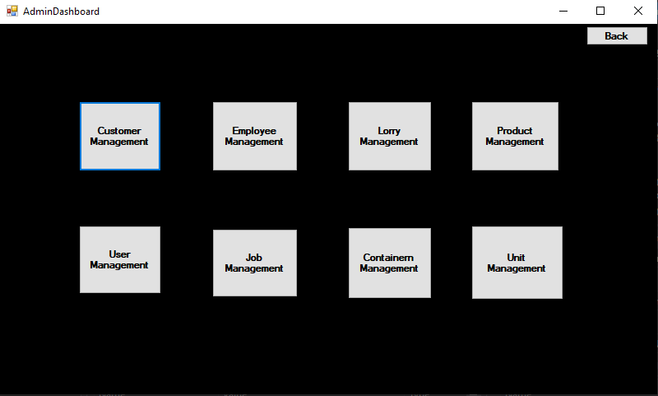

Admin Dashboard contains the entry points in order to access major management areas of this system. Once user click on a particular area user will be navigated to the relevant form of that management area.

## Customer Management

According to following image, all the customers will be shown in the table whereas the form getting loaded. Once you click on a particular row, the relevant customer would be copied to the text boxes and so the admin can update or delete the customer. Update and delete buttons will not be enabled until the user click on a row in the table.

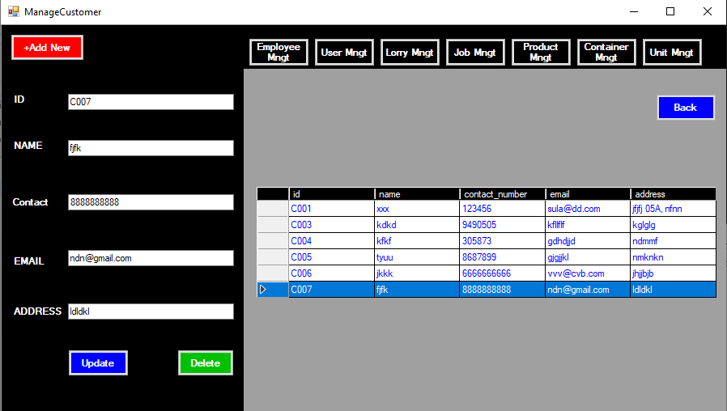

## Employee Management

According to following image, all the employees will be shown in the table whereas the form getting loaded. Once you click on a particular row, the selected employee would be copied to the text boxes and so the admin can update or delete the employee and can be assigned a job position as well. Update and delete buttons will not be enabled until the user click on a row in the table.

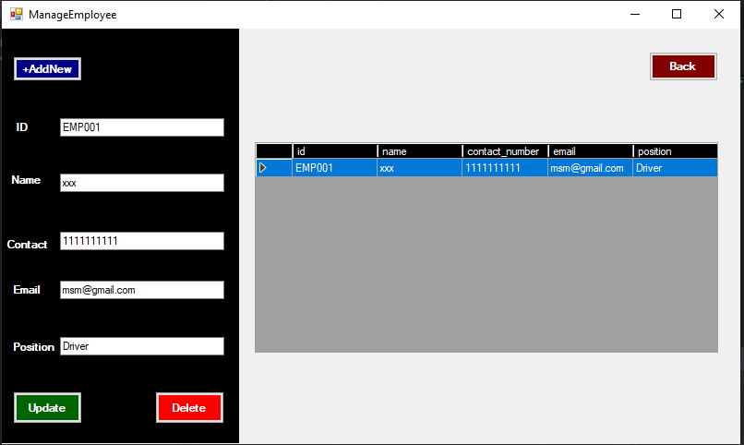

## Lorry Management

According to following image, all the Lorries belongs to the company will be shown in the table whereas the form getting loaded. Once you click on a particular row, the selected lorry would be copied to the text boxes and so the admin can update the current status of the lorry or delete it and can. Update and delete buttons will not be enabled until the user click on a row in the table. Once you click on the ‘+Add New’ system will automatically generate a new id to the lorry whereas button ‘update’ change its name to ‘save’. So then you can save the new lorry to the database.

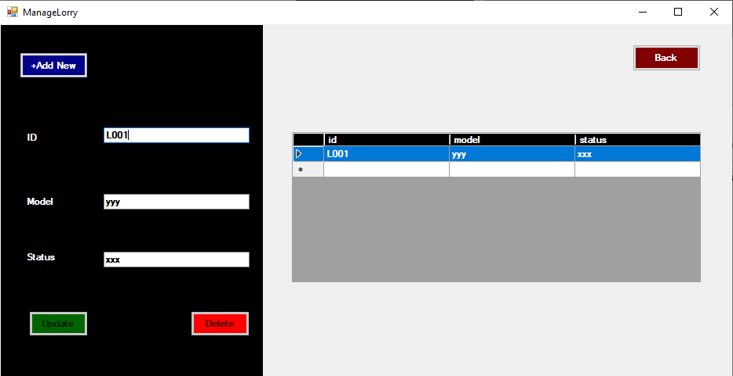

## Product Management

According to following image, all the products belongs to a particular job id will be shown in the table whereas the form getting loaded based on the given job id in the job id text box. Once you click on a particular row, the selected product would be copied to the text boxes and so the admin can update the current quantity of the product or delete it. Update and delete buttons will not be enabled until the user click on a row in the table. In order to add a new product +Add New has to be clicked and then then the system will automatically generate a new ID for the new entity and button Update will change its text value to ‘Save’. So once the ‘Save’ button is clicked new information regarding the product will be saved in the database.

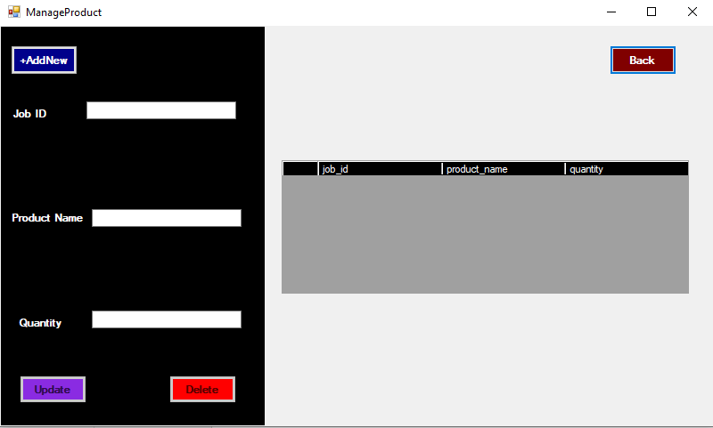

## User Management

According to following image, all the User Management functionalities are going under this form. You can add users under two roles that is ‘admin’ and ‘customer’. Customers deserves the customer privilege. Selected employees are added with the admin privilege. So you can select a customer or employee id from the drop down box and add to the database. Thereafter they will be able to access the system based on their role. Users who are having the admin privilege will be redirecting to the admin dashboard after login and customers to the customer dashboard. Like in previous modules you cannot create new users here. Instead of that this form only allows you to add registered customers and employees as the system users.

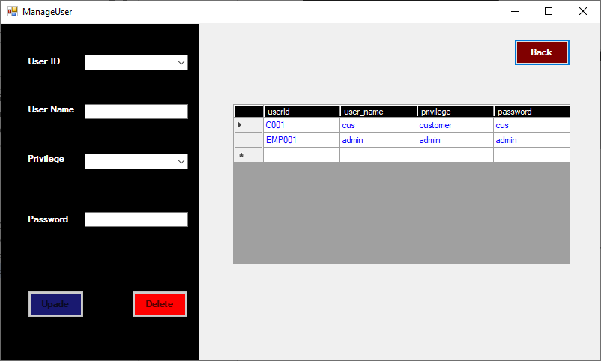

## Job Management

According to following image, all the Job are managing under this form. You can add new jobs and assign a available unit to the job as per the customer request. In order to add a new job first click on the ‘Add New’ and system generates a new job id. Once you click on it button ‘update turn its name to ‘save’. Select the job date that the job should be completed through the date picker and also mention the unit id that should be assigned. After clicking on the ‘save’ new data will be saved in the database. By selecting a row in the table, selected job details will be copied to the form elements and so you can edit or delete that particular job.

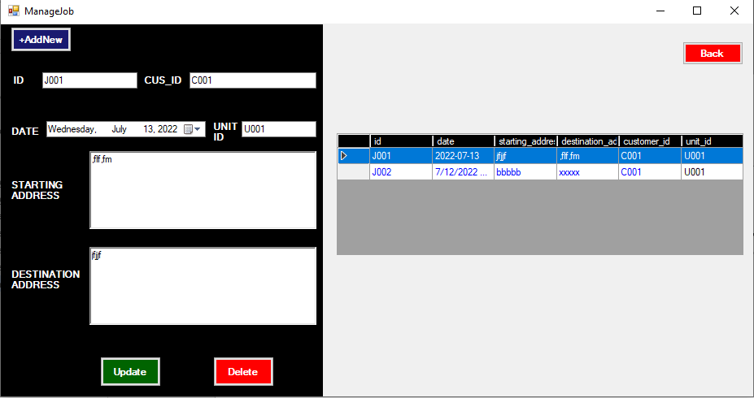

## Container Management

According to following image, all the Containers belongs to the company will be shown in the table whereas the form getting loaded. Once you click on a particular row, the selected container details would be copied to the form elements and so the admin can update the container details or delete it. Update and delete buttons will not be enabled until the user click on a row in the table. Once you click on the ‘+Add New’ system will automatically generate a new id to the container whereas button ‘update’ change its name to ‘save’. So then you can save the new container to the database.

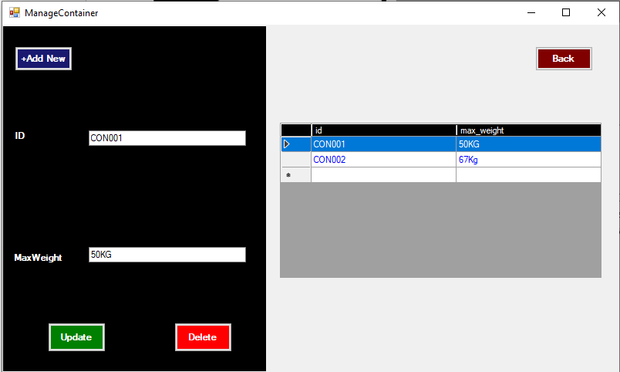

## Unit Management

According to following image, all the Units that already created will be shown in the table whereas the form getting loaded. Once you click on a particular row, the selected unit details would be copied to the form elements and so the admin can update the unit details or delete it. Update and delete buttons will not be enabled until the user click on a row in the table. Once you click on the ‘+Add New’ system will automatically generate a new id to the unit whereas button ‘update’ change its name to ‘save’. So then you can save the new container to the database. This is the place where you can assign a driver and an assistant and a container to a particular unit.

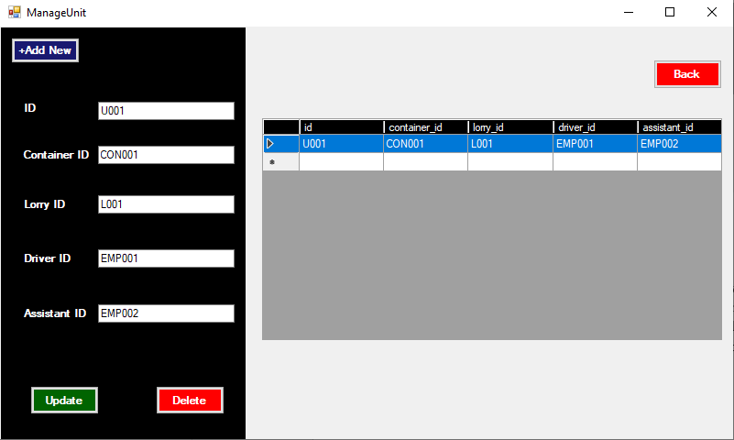

## Guide lines for Customer functionalities

## Customer Registration

As mentioned in the login page, new customers must be registered with the system. So customer needs to go to registration page by clicking on the register button in the login page, Fill the required details and click on the register button in the registration page. Once the admin approved the customer as a user. Then customer will be able to login as customer

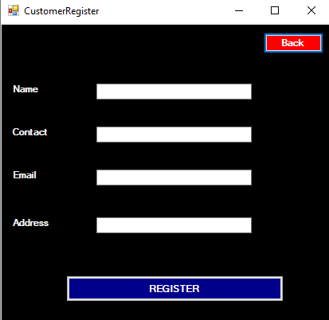

## Customer Dashboard

Customer Dashboard contains the entry points in order to access customer profile module and request for a job module. Once logged customer click on a particular module, he/she will be navigated to the relevant form. The image given below provide a more clear idea.

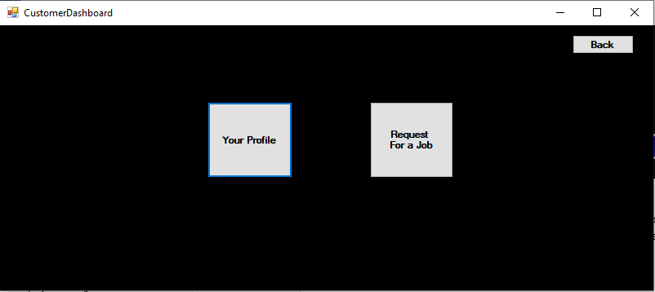

## User Profile

The image given below show the user profile form and is used to display and update registered customer information. This can only be accessed by the customer who is the owner of the relevant profile. So he/she can display their own details and update the details just clicking on the update button.

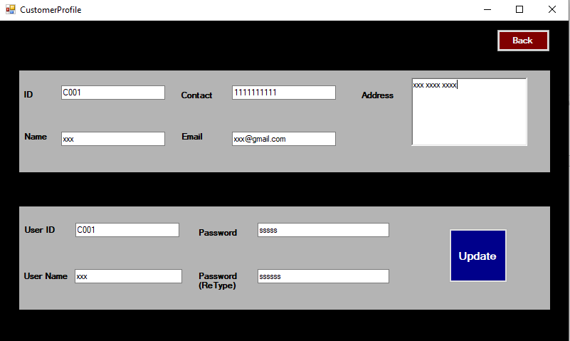

## Request For a Job

According to following image, all the Job request from the customers side should be done here.The requests that has already been created by the particular customer will be shown in the table whereas the form getting loaded. Once you click on a particular row, the selected job details would be copied to the form elements and so the customer can update the product info or cancel it. Update and delete buttons will not be enabled until the user click on a row in the table. Once you click on the ‘+Add New’ system will automatically generate a new id for a new job whereas button ‘update’ change its name to ‘save’. So then you can save the new job to the database. Once the admin approve the job, the status will be updated to ‘approved’.

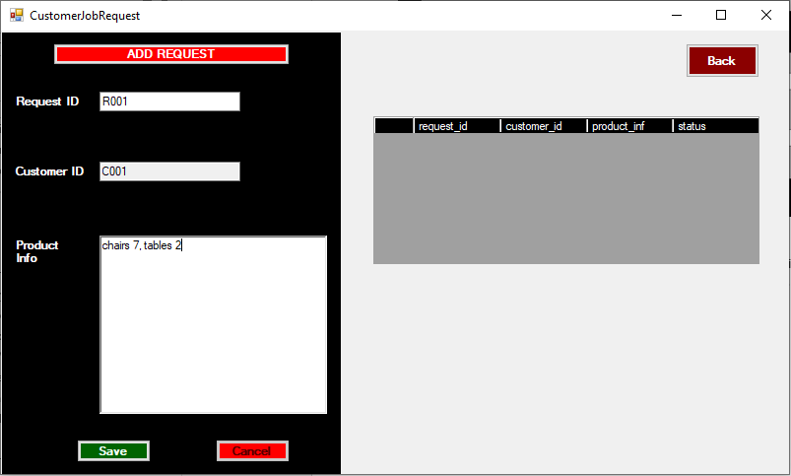

### 2.4.2.Non-Functional Requirements

A **non-functional requirement** is a requirement that specifies criteria that can be used to judge the operation of the system. The functional requirements define specific behavior or functions

* **Reliability** – The system must perform in a reliable manner where the learners and employees can keep trust on the system.
* **Accuracy** – The system should provide accurate and correct information to the students who are using the system.
* **Security** – The system must work according to a strict security mechanism where it should allow only authorized person to log in to the system where a third party cannot make any changes. In this system Online company management system only administrator and students can be logged in.
* **Backup** – Since this system carries hardly gained data, it must be backed up in a regular manner to avoid unnecessary and unexpected data losses.
* **Scalability** – The system should be easily expandable and store more data without any problems, as the Ranjith company is large student based with many branches.
* **Interoperability** – The system should work greatly with other applications such as servers, databases without interfering to any performances.
* **User-friendliness** – The system should be easily handled and understand by a novel as well as existing users. It means the learning curve of the new systems must be relatively low with a complete user friendliness.
* **Availability** – The system should available at any time in order to get relevant details and insert the information.

## 2.5.Selection of the Process Model

After concentrating on lots of general software process models it is decided to stick with Rational Unified Process as the main development methodology by comparing its pros and cons. Though it has been decided to carry on with the concepts of Rational Unified Process also took the advantages of some other process models as well.

The software process model may be defined as a simplified description of a software process, presented from a particular perspective. In essence, each stage of the software Process is identified and a model is then employed to represent the inherent activities associated within that stage. Examples of models include the workflow model, the data-flow model, and the role model. In contrast to software life cycle models, software process models often represent a networked sequence of activities, objects, transformations, and events that embody strategies for accomplishing software evolution. Such models can be used to develop more precise and formalized descriptions of software life cycle activities. Process models are briefly described below.

## 2.6.Methodology for the Proposed System

Rational unified process model (RUP) was chosen from the above explained models. The Rational Unified Process (RUP) is an iterative software development process framework created by the Rational Software Corporation, a division of IBM since 2003.RUP is not a single concrete prescriptive process, but rather an adaptable process framework, intended to be tailored by the development organizations and software project teams that will select the elements of the process that are appropriate for their needs. RUP is a specific implementation of the Unified Process. [10] The RUP has determined a project life cycle consisting of four phases namely: Inception, Elaboration, Construction and Transition. Brief descriptions of each phase are given below.

* **Inception phase**

In this phase the business case which includes business context, success factors and financial forecast is established. To complement the business case, a basic use case model, project plan, initial risk assessment and project description are generated. So before developing this system a basic system use case model was drawn and project was planned.

**• Elaboration phase**

The primary objective is to mitigate the key risk items identified by analysis up to the end of this phase. The elaboration phase is where the project starts to take shape. In this phase the problem domain analysis is made and the architecture of the project gets its basic form. Problems of the current Ranjith company was identified to get an idea about the requirements.

**• Construction phase**

The primary objective is to build the software system. In this phase, the main focus is on the development of components and other features of the system. This is the phase when the bulk of the coding takes place. System was developed module by module in an orderly manner.

**• Transition phase**

The main objective is to 'transit' the system from development into production, making it available to and understood by the user. The activities of this phase include training the end users and maintainers and beta testing. If all objectives are met, the Product Release Milestone is reached and the development cycle is finished [2].

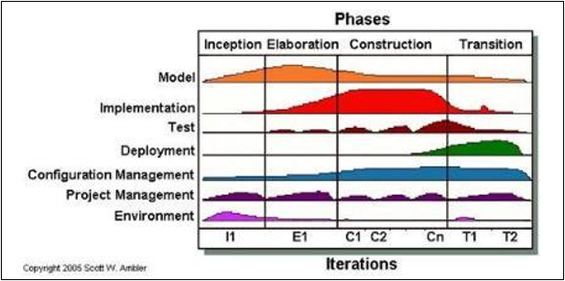

Figure shows the RUP life cycle

# CHAPTER: 03 - DESIGN

## 3.1.Introduction

Design is essentially the bridge between requirements specification and the final solution for satisfying the requirements. The goal of the design process is to produce a model or representation of a system, which can be used later to build that system. The produced model is called the design of the system. The design of a system is essentially a blueprint or a plan for a solution for the system.

The approach of Object-Oriented Design which is a process of planning a system of interacting objects was used for the purpose of modeling the system. UML (Unified Modeling Language) which is a standardized general-purpose modeling language in the field of object-oriented software engineering was used to develop the visual diagrams of the system.

.

## 3.4. Object Oriented Analysis and Design of the System

Object oriented analysis and design (OOAD) is a popular technical approach for analyzing and designing an application, system, or business by applying object-oriented programming, as well as using visual modeling through the development lifecycles to faster better stakeholder communication and product quality. According to the popular guide Unified Process. OOAD in modern software engineering is best conducted in an iterative and incremental way [2].

### 3.4.1. High Level Use Case Diagram for The Proposed System

|  |  |
| --- | --- |
| Use case Name | User Login |
| Pre- Condition | User must be registered in the system |
| Primary actors | Manager (Administrator), Students |
| Main flow | 1. Use case starts when system prompts the user to enter User name and the password 2. User enters User name and Password. 3. System validates User name and Password. 4. User case ends with system grants user to the relevant user privilege |
| Post conditions | 3. a. System generates an error message if username and password invalid. |

The high-level use case diagram of the proposed system is given below. Use case diagram is a methodology that used in analysis to identify, clarify, organized requirements. This diagram illustrates set of actions collaboration with users, gathered requirements including internal, external influences and how the users will interact with proposed system . following table shows the case narrative of the login module

Table 3.4.1 Use case narrative mode

**Use case diagram**



use case diagram for the login module

### Class diagram

A class diagram in the Unified Modeling Language (UML) is a type of static structure diagram that describes the structure of a system by showing the system's classes, their attributes, operations (or methods), and the relationships among objects.

The class diagram is the main set up of object-oriented modelling. It is used for general conceptual modelling of the system of application. Class diagram can also be used for data modeling. The classes in a class diagram represent both the main elements, interactions in the applications, the classes to be programmed, class diagram for the system is illustrates in the following figure

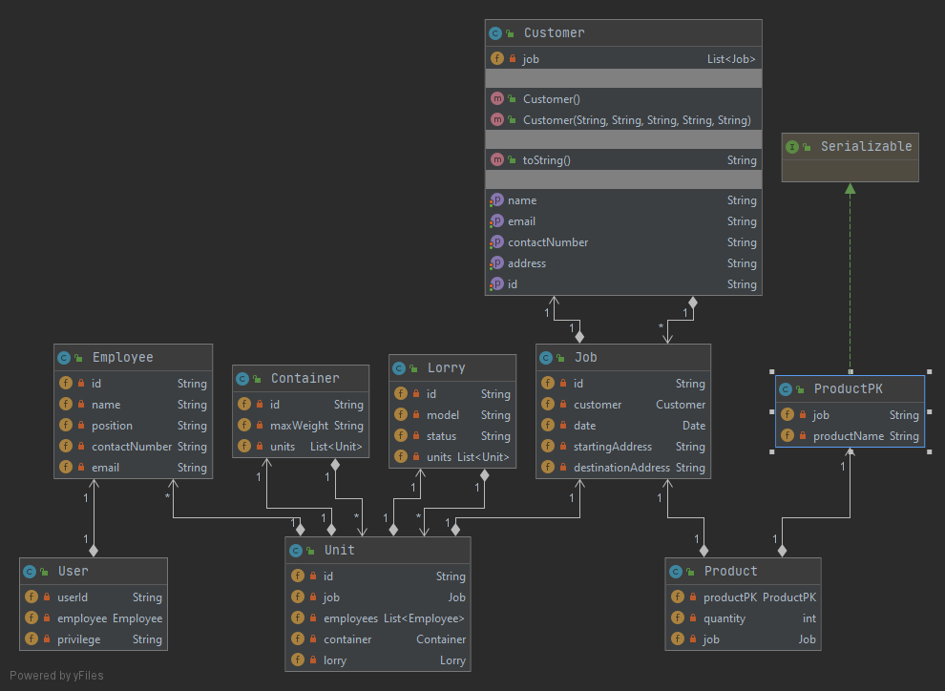

### ER Diagram

“The basic design of the database is described with the aid of an ER diagram. The entities, attributes and their relationship are clearly understands through this.figure given below.shows the ER diagram of the system.

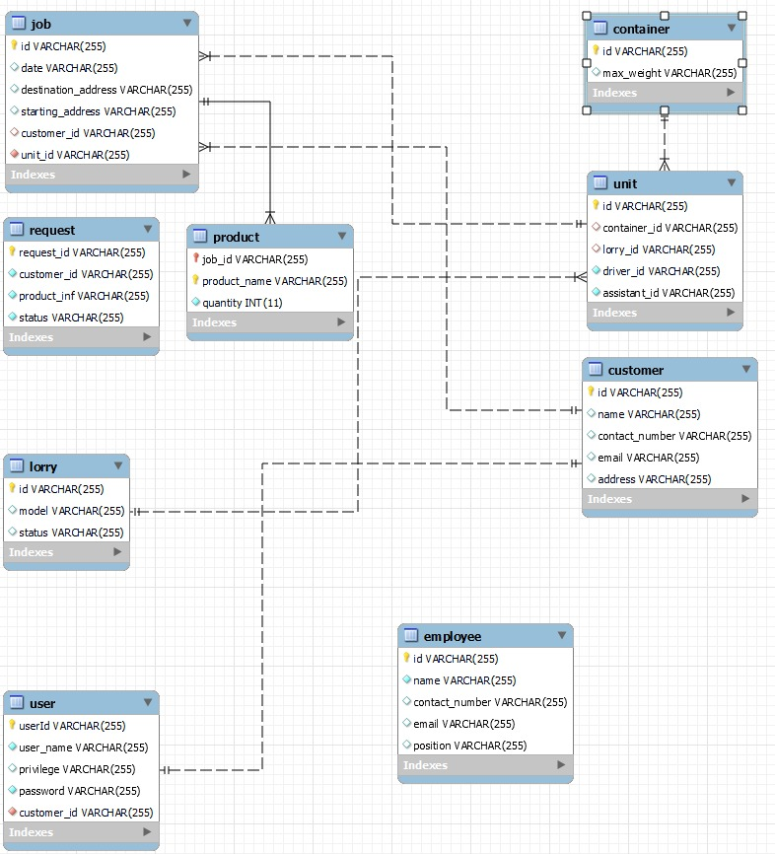

## User Interface Design

User Interface (UI) design deals with the applications and the user. Hardware devices and software applications are controlled by people using interfaces. UI has the big impact on how much the users enjoy using the application and how easy to use the application. Graphical User Interfaces (GUI) means graphical controls which make the interface attractive like windows, buttons, toolbars and menu bars. GUI provides a user-friendly experience to user to interact with the software in a natural and friendly way. In the system following user interface (UI) components are used [12]

USER INERFACE DESIGN PRINCIPLES.

 Consistency- should be consistent in possible, comparable operations should be activated in the same way.

 User Familiarity – use terms and concepts from the experience of people who use the system. Currently developing system is user friendly, anyone can handle without the technical knowledge.

 User guidance – the interfaces should provide meaningful feedback errors occur and provide help facility to solve out that.

 User diversity – the interface should provide appropriate interaction facility for the different types of users who is interactive with the system.

 Minimal surprise – users should not be surprised by the behavior of the system. System should be adaptable to the users.

 Recoverability – the interfaces should contain mechanisms to allow users to recover errors in a good way.

Following design rules were used in designing the system. They are listed below.

➢ Eye friendly colors were used when developing the home page and menu bars of the online company management system.

➢ After delete, update, saving a record system should show successful messages as well as if anything saved without entering correct data system should pop up with and alert massage as to fill up.

➢ To increase the effectiveness of the system keyboard shortcuts are used instead of mouse click.

➢ Meaningful names and texts are used for labels, forms and buttons.

# IMPLEMENTATION

## Introduction

After successful completion of design phase, Implementation phase is carried out according to what the design stage planed by using appropriate tools and techniques. This is a very important stage on a Software development life cycle. The output of this stage is effective executable system. The major code segments, tools and techniques used to implement the system in the implementation environment are mainly focused in this chapter.

## Implemented Environment

This has two major categories, Hardware and Software environments are mentioned here. Following table tells what a computer is required to have in the hardware aspect as well as software aspect.

|  |  |
| --- | --- |
| HARDWARE ENVIRONMENT | SOFTWARE ENVIRONMENT |
| Intel (R) Pentium (TM)4@CPU 3.0GHz | MS Window 10 |
| 4GB RAM | C#.Net |
| 160GB HDD | MYSQL Server |
|  |  |

Table 4.2 Implementation Environment

## Justification for the choice of Implementation platform.

Microsoft Windows have been used to develop the System. This can be found in normal Computer based Organizations other than MacOS, Linux or Ubundu. No need Well Information technology professionals to handle this kind of platform. The Company which was chosen does not have more employees as well as the employees currently working there do not have much Information technology knowledge. So a normally easily can be handled platform was used to make this System

# EVALUATION

## Introduction

“The process of developing a software product using software engineering principles and methods is referred to as a software evaluation. This includes the initial development of Software, it’s maintenance and updates till the desired software product is developed, which satisfies the expected requirements” [10].

Quality and the reliability of the system is another key aspect of making the web-based system a success. Following testing types were used to test the system.

* Unit Testing
* Integration Testing
* System Testing
* User acceptance testing
* White-box Testing
* Black-box testing

### Unit Testing

This is done for individual units. Unit testing is a software development process in which the smallest testable parts of an application, called units, are individually and independently scrutinized for proper operation. Unit testing can be done manually but is often automated Unit testing is a software development

Unit testing find the defects of each and every unit of the application at initial level of testing. This Window based system is developed step by step by testing each n every codes. Unit tests improves the quality and reliability.

### Integration Testing

Integration testing is carried out after the separate software modules and unit testing. This is based on the functional specification of the system. Integration testing is the phase in software testing in which individual software modules are combined and tested as a group. It occurs after unit testing and before validation testing. Integration testing takes as its input modules that have been unit tested and groups them larger aggregates, applies tests defined in an integration test plan to those aggregates, and delivers as its output the integrated system ready for system testing .

Web-based systems each module is tested step by step after performing unit test. Individual software modules are combined and tested as groups. Integration test is conducted to evaluate the compliance of the system with the specific functional requirements.

### System Testing

The purpose of system testing is to prove that the software meets the agreed user requirements and works in the target environment and covers both functional and nonfunctional requirements. System testing of software or hardware testing is conducted on a complete, integrated system to evaluate the system’s compliance with its specified requirements. System testing fills within the scope of black box testing, should require no knowledge of the inner design of the code or logic [16].

After completing module testing, system is tested fully by considering its functionalities. The purpose of this test is to evaluate the end-to-end system specifications.

### User acceptance testing.

This is end user testing. User acceptance testing is a phase of software development that software is tested in the” real world” by the intended audience. UAT can be done by in house testing here volunteers or paid test subjects use the software or, more typically for ideally distributed software, by making the test version available for downloading and free trial [13].

Web-based company management system was given to an employee of the firm to test the favorable functionalities of the system.

### Regression Testing

Regression testing is the process of testing changes to computer programs to make sure that the older programming still works with the new changes. Regression testing is a normal part of the program development process and, in large companies, is done by code testing specialists. Test department coders develop code test scenarios and exercises that will testing units of code after they have been written.

### .Whitebox testing

White box testing is detailed investigation of internal logic and structure of the code. It’s also called the glass testing or open box testing.to perform white box testing on an application, tester needs to know internal working of the code

Window based sales and inventory systems internal code structures were finally checked and tested by the supervisor.

### 5.1.7. Black box testing.

The technique of testing in out having any knowledge of the interior workings of the application is called black box

## System test plan.

System test plan ensures that initially there is a list of tasks and objectives to track the progress of the project. “A document describing the scope, approach, resources and schedule of intended test activities. It identifies among others test items, the feature to be tested, the testing tasks, who will do each task, degree of tester independence, the test environment, the test design technique and entry and exit criteria to be used, and the rationale for their choice, any risks requiring contingency planning. It is a record of the test planning process

## 5.3System test cases.

A test case is a set of conditions or variables under which a tester will determine whether a system under test satisfies requirements or work correctly. Test cases include the test case title, inputs, expected results and the priority. The process of developing test cases can also help to find problems in the requirements or designs of an application.